ATU LETTERKENNY
ASSIGNMENT COVER SHEET

Lecturer’s Name: Danny Mc Fadden
Assessment Title:
Work to be submitted to: Blackboard via Turnitin
Date for submission of work:
Place and time for submitting work: Blackboard via TurnItIn by

To be completed by the Student

Student’s Name: Imran Haroun
Student Number: L00196892
Class: MSc Cybersecurity 2025-2026
Subject Module: Threat Management 1
Word Count (where applicable):
I confirm that the work submitted has been produced solely through my own efforts.
Student’s signature: Imran Haroun Date: 03/01/2026

Notes
Penalties: The total marks available for an assessment is reduced by 15% for work submitted up to one week late. The total marks available are reduced by 30% for work up to two weeks late. Assessment work received more than two weeks late will receive a mark of zero. [Incidents of alleged plagiarism and cheating are dealt with in accordance with the Institute’s Assessment Regulations.]
Plagiarism: Presenting the ideas etc. of someone else without proper acknowledgement (see section L1 paragraph 8).
Cheating: The use of unauthorised material in a test, exam etc., unauthorised access to test matter, unauthorised collusion, dishonest behaviour in respect of assessments, and deliberate plagiarism (see section L1 paragraph 8).
Continuous Assessment: For students repeating an examination, marks awarded for continuous assessment, shall normally be carried forward from the original examination to the repeat examination.

SECTION A
Question 1: Explain Packet 52 and 53?
Answer:
The screenshot below displays Packet 52’s host device with a source IPv4 address of 172.18.9.51 sending a ping request and receiving a corresponding ping reply from Packet 53’s source IPv4 address of 172.18.9.206. The host devices for Packets 52 and 53 both use IPv4. Packet 52’s source IPv4 Address and Packet 53’s source IPv4 address show observations of close network proximity due to the round-trip time between both devices, which was 0.286ms. The frame length for both Packets was confirmed to be 74 bytes, the minimum permissible for data transmission.
The screenshot shows the TTL (time to live) as 128 on Packet 52, which is the total number of network hops completed by that Packet before it’s discarded (AngryIPScanner, n.d.); However, it remains at 128, indicating the Packet was captured before a router forwarded it.
Since both Packet 52’s host device and Packet 53’s host device list each other as the destination MAC address and the addresses remain unchanged, it indicates both devices are on the same layer two network, as routers reconfigure ethernet frames at every hop.
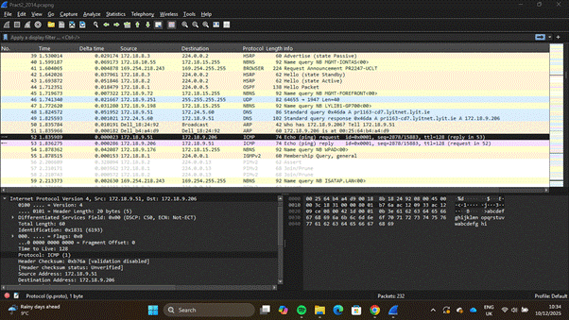

Question 2: What filter could be used to identify this type of traffic?
Answer:
In the Screenshot below, a filtered Wireshark response is displayed. The screenshot shows the ICMP used by different Packets during information exchange. Filters are rules applied to network analysis tools to limit either recorded traffic or analysed traffic. Analysed traffic is the traffic obtained after capturing network traffic, and is the filter highlighted in this section and the screenshot below. ICMP traffic in Wireshark can be filtered in various ways, including:
1. Filtering by protocol, e.g. ICMP, which gives a list of all captured ICMP traffic on Wireshark
2. Filtering by type where icmp.type==8 returns echo ping requests, and icmp.type==0 returns echo ping replies.
3. The ip.proto==1 filter is another filter command that can be used to display ICMP traffic. This works because each protocol has a fixed number assigned by IANA(IANA, 2025), so the command returns the IP address of the specified value.
4. The icmp.checksum_bad==1 command could also be used to filter ICMP traffic with invalid checksums.
5. The icmp.ident(>, ==, <) number e.g icmp.ident==0x0001 command is usually used to track echo ping requests and replies. The screenshot below highlights only a single identifier, as that was the only ICMP ping session captured during the network traffic capture process.
6. The icmp.seq(<, ==, >) number e.g icmp.seq == 2879 command is used to match ping requests to ping replies and can be used to analyse Packet loss between devices sending and receiving information.
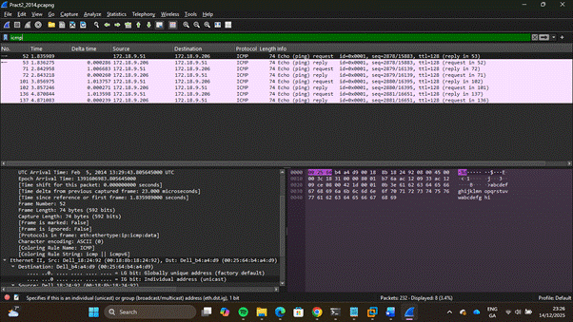

Question 3: Why can’t we create a filter based on Layer 4?
Answer:
The screenshot below highlights an attempt to apply a filter based on layer 4 of the seven-layer OSI model. It displays various results, including intended and unintended replies, referring to the transport protocol used to transfer data over a network. To know how Wireshark filters Packet information, the Wireshark Packet decoding method must also be discussed.
Wireshark utilises Packet decoding, and each decoder in a protocol stack decodes the part of the protocol it’s responsible for by identifying the encapsulated data through header fields and delegating the resulting data to subsequent protocol decoders based on their protocol identifiers. As transport protocols can be treated as containers, after they’ve been decoded by Wireshark Packet decoders, multiple protocols that were being contained in the transport protocol are then exposed, and the highest protocol layer that satisfies the filter criteria is then displayed in the filtered responses(Wireshark, n.d.).
While filtering by transport protocols may not be wrong from a systematic point of view, the reliance of information on the transport layer alone for inference is significantly limited due to generic nature of the transport layer it presents itself, so when a network analyst is filtering based on all traffic that uses tcp or udp, there’s no point of correlation to be found in the different protocols being assessed as there are no baseline similarities that can be used to understand the network traffic being evaluated. In evaluating the network traffic captured during the screenshot below this becomes a key observation as applied UDP transport protocol filters demonstrated minimal functional quantitative output about the network behaviour and a general baseline for understanding network traffic, the exclusion of all transport protocol traffic presents itself as a step that an analyst could take to filter unwanted traffic and focus on traffic that outlines specific network activity.
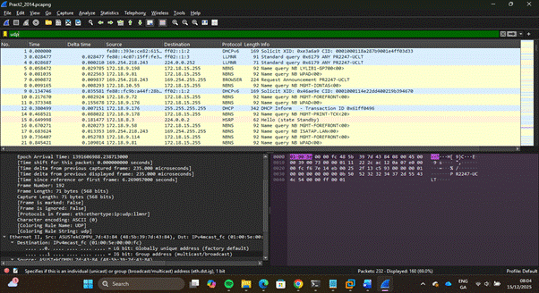

Question 4: What does Packet 49 give an answer to?
Answer:
The screenshot below highlights Packet 49, A standard DNS query in response to a DNS query by Packet 48’s client host device. Packet 49’s DNS Server resolves a queried domain name from packet 48’s source client device into an IPv4 address using an A record.
Packet 49’s host device also appears to be using UDP as its transport protocol, with the source port of Packet 49’s host device being 53, a port utilised by DNS servers(Smith, 2024), suggesting the Packet is coming from a DNS server. The captured traffic also indicates the source and destination addresses of the DNS server and client; it can then be inferred that a client device with a source address of 172.18.9.51 sent a DNS request from port 49402 to port 53 on the DNS server, with a source address of 172.24.5.60. Packet 49, displayed in the screenshot below, highlights the DNS response. It reveals a DNS reply from port 53 back to the client’s device port that made the request using UDP.
Packet 49’s host device appears to be a proxy device acting as an intermediary between Packet 48’s client host device and the DNS server, The observed TTL value of 127 and the differing IPv4 address range between both devices further corroborates the evidence of an intermediary device consistent with the behavior of a router acting as a proxy, due to the network hopping from Packet 49’s host device captured and then observed in Wireshark. The time taken for Packet 49’s host device to forward a response to Packet 48’s was 1.021ms, indicating that the two devices are separated by a significantly remote distance, possibly in the same metropolitan area. Given the time of arrival of 127 by Packet 49’s host device, it also suggests that the device has been transmitted through a single hop and could be running on a Windows-based system (angryip, n.d.).
DNS is a naming system that translates human-friendly domain names into IP addresses that systems on a network use to communicate with one another. It uses different record types to perform this function, such as responding to a query with an A record that resolves to a 32-bit IPv4 address. A records map hostnames to IPv4 addresses. AAAA record, an IPv6 A record, which resolves to a 128-bit IPv6 address. A CNAME record which is a canonical name record that makes use of a secondary name which maps to a primary name that the DNS lookup will make use of to retry a lookup, a MX record which is a mail exchange record that specifies a list of mail exchange servers that resolve emails to domains, the DNS also makes use of multiple other types of methods to perform its operation(Kaplarevic, 2024)

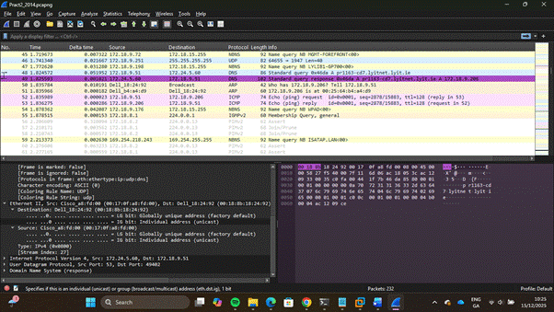

Question 5: What is the hostname for the device with IP 172.18.9.206
Answer:
The Screenshot below displays a domain name of pr1163-cd7.lyitnet.lyit.ie, this domain qualifies as a fully qualified domain name because it is the complete DNS name that identifies a specific host in the global DNS naming system(Alexandrea et al., 2022). The source domain name shown in the screenshot below was obtained using Wireshark’s name resolution feature. Name resolution is a feature that allows an analyst to resolve physical addresses, network addresses and transport addresses. The domain was revealed by using the name resolution feature to resolve network addresses.
The time taken for an ICMP ping reply to an initial ICMP ping request, along with the TTL and source IPv4 address, supports the inference that the address resolves to an internal address. Furthermore, it can be inferred that the internal service with a source address of 172.18.9.206, corresponding to the domain pr1163-cd7.lyitnet.lyit.ie, and a unique identifier of pr1163-cd7, has access to the internal network.
A fully qualified domain name contains a hostname, a domain and a top-level domain. A hostname is an assigned label to a device or service in a network. A subdomain precedes the main domain and serves as a subdivision or service of the domain. A domain name consists of a second-level and a top-level domain. FQDNs can be used for website access, email delivery, server management within a network, and to associate specific FQDNs with SSL certificates (Alexandrea et al., 2022). The pr1163-cd7.lyitnet.lyit.ie consists of a hostname of pr1163-cd7, a subdomain of lyitnet.lyit, a domain name of lyit.ie and a top-level domain of ie.
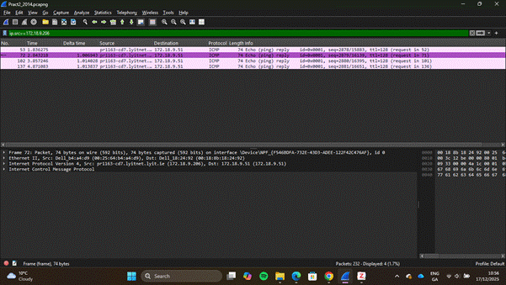

QUESTION 6: What subnet is the device on if the subnet mask is 255.255.248.0 or a /21 network prefix?
ANSWER:
The screenshot below highlights the source IPv4 address 172.18.9.206 of a device on the 172.18.9.0/21 subnet captured during a network traffic capture. This value was determined using octet subnetting.
Subnetting is the process of dividing large networks into smaller subnets, organised into different groups based on a 32-bit IPv4 address. Subnets are smaller networks that enable communication between devices within a subnet without unauthorised interaction with devices on other subnets in the local network and external networks (Singh, 2025). There are four octets in a subnet, each with a maximum value of 255.255.255.255, also known as the broadcast address. Each octet is split into eight parts calculated in powers of 2, e.g 2⁰=1 up to 2⁸=128.
Octet subnetting involves the selection of an octet in the 32-bit IPv4 subnet and utilising the octet to segment the network based on the network and host portion in the network’s IPv4 address. Subnet masks are used to identify and determine the increment of the subnet address range (Flackbox, 2021). Examples include:
1. An IPv4 address of 172.16.50.23 with a subnet mask of /23, the corresponding network address is 172.16.50.0, the /23 notation blocks increment in multiples of 2, which results in the subsequent subnet beginning at 172.16.52.0.
2. An IPv4 address of 192.168.127.15 with a subnet mask of /21, the corresponding network address is 192.168.120.0, the /21 notation blocks increment in multiples of 8, which results in the subsequent subnet beginning at 192.168.128.0.
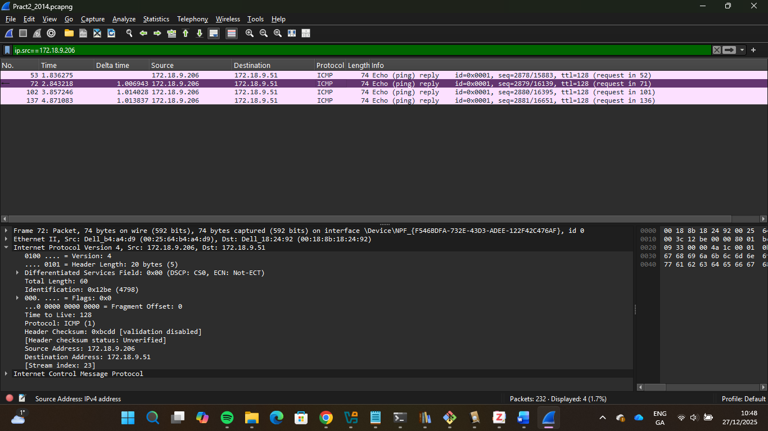

Question 7: How many Packets of the type found in Packet number 52 and 53 were captured?
Answer:
The screenshot below shows eight captured Packets, including Packets 52 and 53. A series of four ICMP ping echo requests and corresponding ICMP echo ping replies through the use of the ICMP filter is presented in the screenshot below, which is consistent with a windows OS ping behavior unlike the linux or macOS that transmit continuous ping commands(M, 2023), this however does not establish the system utilises a windows OS, since wireshark displays ping traffic uniformly irrespective of OS of device. It establishes basic network connectivity between the two devices with no observed Packet loss. The data below highlights an ICMP echo ping sequence used to verify device reachability, not device performance.
The Windows-specific default ping command is used to test basic connectivity between devices; however, both Linux and macOS use the ping command as a dedicated monitoring tool in troubleshooting network issues, and a “Ctrl+C” command terminates the ping process from running indefinitely. A challenge presents itself in the use of Windows OS specific ping commands. Windows' default ping process is insufficient to capture periodic network glitches, and monitoring device behaviour over longer durations is a more challenging task (M, 2023).
There are extra options that could be included in the ping command to give more detailed results, such as(IBM, 2024):
1. Ping -c count: States the total number of echo requests to be sent and received.
2. Ping -in timeout: This works with only the -c command, and delays the ping command to wait for maximum timeout seconds to obtain a reply.
3. Ping -d: This command initiates socket-level debugging.
4. Ping -f: This specifies the flood ping option and sends out packets at the rate they are received or up to one hundred times per second, depending on which is faster. The -f flag is incompatible with the -i wait flag and can only be used by the root user.
5. Ping -i wait: There is a period of temporary suspension controlled by the wait variable, which determines the interval between sending each packet.

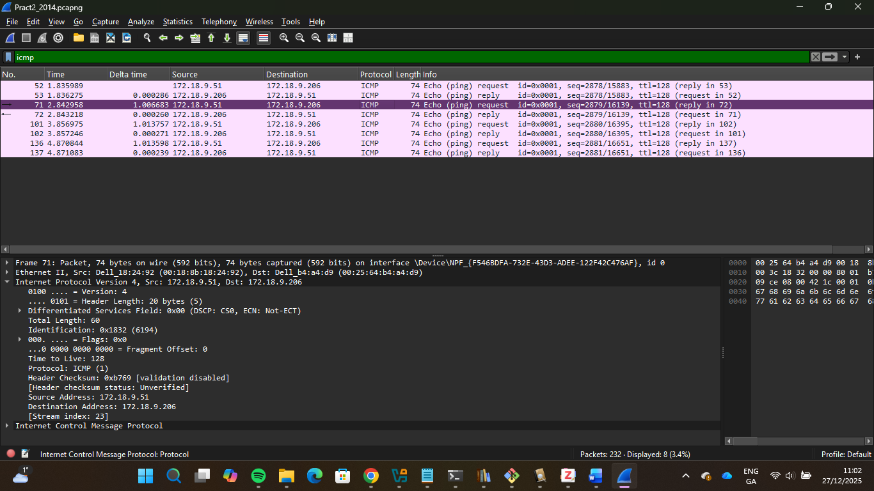

Question 8: What is the function of the protocol in use in Packets 52/53?
Answer:
The screenshot below highlights ICMP traffic, shown in Packets 52 and 53, through the analysis of a network traffic capture by making use of Wireshark. ICMP is used to diagnose network communication and confirm data reachability. ICMP does not use ports and is not a TCP/UDP connection, as it is a network-layer protocol and not a transport-layer protocol. TTL is a part of the IPv4 header and indicates the number of times a Packet can be forwarded by a router before being dropped. The traceroute command uses the time-to-live (TTL) to map out intermediaries between the two machines by sending continuous ping requests with a small TTL to gather information about devices that reply with an unreachable message. ICMP is also critical to the neighbour discovery protocol in IPv6 (Techknowsurge, 2022).
While Time to Live is critical for IPv4 traceroute in ICMP, Hop Limit is equally essential for IPv6 traceroute in ICMP. Hop limit is the total number of times an IPv6 Packet can be forwarded by a router before being discarded(Iveson, 2019). The neighbour discovery protocol is an IPv6 protocol that uses ICMPv6 messages, such as router solicitations, router advertisements, neighbour solicitations, and neighbour advertisements, as well as redirects, to perform functions such as stateless address autoconfiguration, address resolution, neighbour unreachability detection, and duplicate address detection (Daniel, 2021).
ICMP, a network-layer protocol that operates on the Internet Protocol due to the unreliability of the Internet Protocol, as there is no frame acknowledgement on the Internet Protocol and no subsequent reply to understand the issue with the network, unlike ICMP. ICMP Packets, also known as IP data, are encapsulated in an IP header to form an IP Packet. When a host device A initiates communication with another host device B, the frame from host device A is routed across multiple routers before finally being routed to host device B, however if the frame is dropped due to router unavailability, there will be a resulting frame loss, in the case of a frame loss the unavailable router forwards back an ICMP frame to the previous router it obtained the Packet from and subsequently to other intermediaries till an ICMP frame is transferred back to host device A with a resulting error message. The ICMP Packet also encapsulates an ICMP header and ICMP data(Anon, 2023)
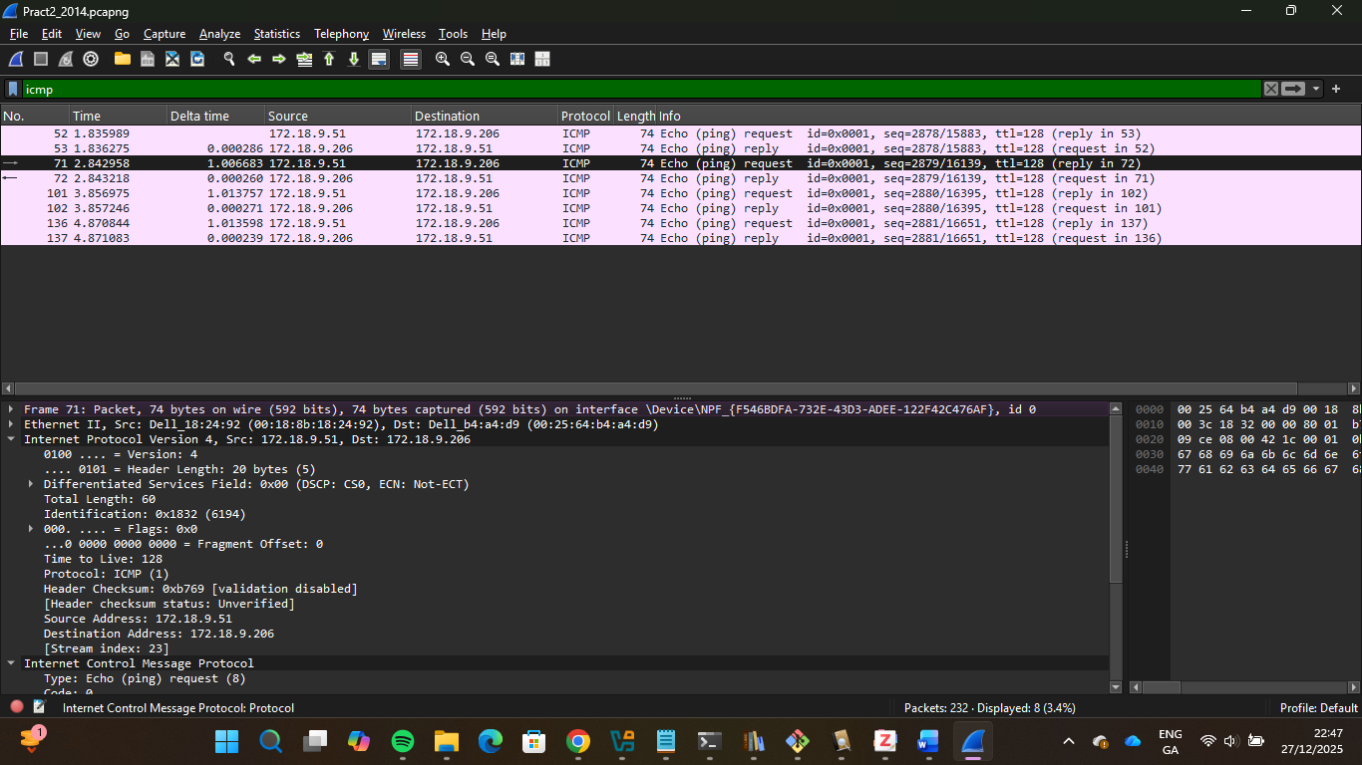

Question 9: Why would it be important to be wary of the type of traffic discussed in the previous questions?
Answer:
ICMP, a network-layer protocol that reveals information about issues experienced during network transmission and can shuttle data between two systems (Gantenbein, 2021). This is an essential function during network transmission; however, it also leaves it vulnerable to attacks such as ICMP tunnelling and ICMP/ping flooding. This is dangerous because distinguishing legitimate traffic from malicious traffic is difficult, as both are treated as regular ICMP activity.
ICMP tunnelling is an attack method that transmits harmful data via a tunnel, encapsulated in ICMP echo requests and responses that appear legitimate, to extract data and secretly execute commands. Installed malware can use the ICMP protocol to interact with an outside attacker by leveraging the trusted nature of the ICMP, which can bypass network segments and firewalls that block incoming and outgoing traffic. An SSH reverse shell can also be inserted as an SSH Packet into the data section of the ICMP datagram that establishes the reverse shell. ICMP tunnelling can be mitigated by configuring the firewall to block outbound pings to external endpoints and to allow only fixed-size ICMP Packets to pass through the firewall (Gantenbein, 2021).
ICMP flood is a DDoS (Distributed denial of service) attack that overwhelms a device's resources by sending continuous ping request Packets. An external attacker utilises multiple compromised systems to send a considerable volume of ICMP echo request Packets to the target device. Echo requests are sent to the broadcast IP address, allowing the Packets to be delivered to all devices connected to the target. A “ping -t <target IP> -l 65500” command can be used to execute a DDoS attack, where the -t flag ensures indefinite ping runs till it’s manually stopped, the -l flag specifies the ICMP payload size with a Packet size of 65500 bytes being the maximum amount allowed by IPv4. The ping flood attack can be mitigated through traffic rate limiting, blackhole filtering, DDoS mitigation services, ICMP protocol blocking, and Infrastructure capacity planning (Grinberg, 2025).
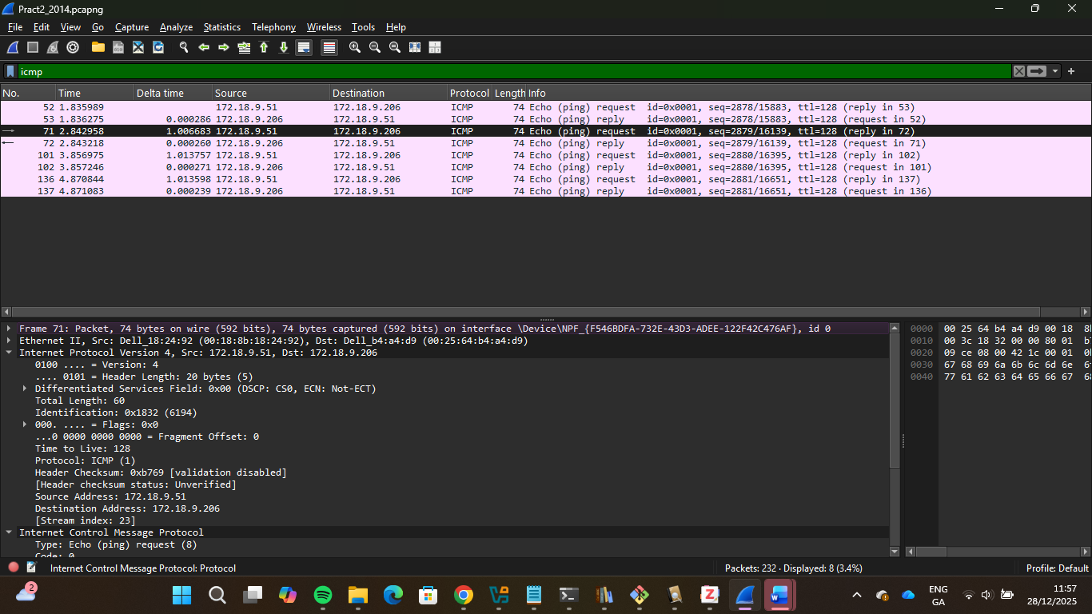

Question 10: What does the following filter do? What name do we give to what it removes? !udp && !arp && !tcp && !icmpv6 && !stp && !pim && !ospf
Answer:
The filter above contains the ! Operator, which means NOT and the && operator, which means AND. The filter removes the UDP, ARP, TCP, ICMPv6, Spanning Tree Protocol, Protocol Independent Multicast, and OSPF protocols. The network traffic being filtered out is all expected and is especially useful for troubleshooting specific network behaviour. By removing all expected protocols, specific network protocols are revealed, helping the analyst understand network behaviour more clearly. “Noise” is the name given to the Packets that the filters displayed in the screenshot below are configured to capture, and it consists of Packets that don’t interest the analyst sifting through the data (Wireshark, n.d.).
IGMP stands for Internet Group Management Protocol. IGMP is utilised by hosts and nearby routers to handle multicast group memberships on IPv4 networks. It facilitates communication between devices and local routers to determine which hosts belong to specific multicast groups within a LAN, with multicast being a one-to-many communication type(Utkarsh, 2025). IGMPv2 is an updated version from IGMPv1 and is the predecessor to IGMPv3, IGMPv2 enables hosts to leave group messages through reporting to the router that it has stopped listening, routers can send membership queries for specific group addresses to hosts when it receives a leave group message to check if any host is still interested in listening to the multicast traffic, maximum response time is a field in query messages that specify how much time hosts have to respond to the membership query, and a querier is an election process for situations when there are two or more routers in the same subnet, the router with the lowest IP address becomes the active querier(Molenaar, 2015).
In the screenshot below, a device functioning as a multicast router with an IPv4 address of 172.18.8.1 sends a general query to all hosts on the 224.0.0.1 multicast group to confirm whether any listening hosts remain on that subnet. Although there’s a newer version of IGMP, IGMPv2 is still in common use as of 2025 due to its continued use in networks with basic multicast management needs and the lack of specialised scenarios that IGMPv3 offers through the source-specific multicast feature (Brightwood, 2024). The screenshot below highlights the TTL value of 1 present in the Packet, this establishes that the Packet can only perform one hop, which means the Packet is restricted to the local network and will be dropped if it’s routed out of the network, as IGMP is used for only hosts in the same local network, the configured TTL value of 1 is a hardening safety mechanism that ensures IGMP traffic is limited to the local network.
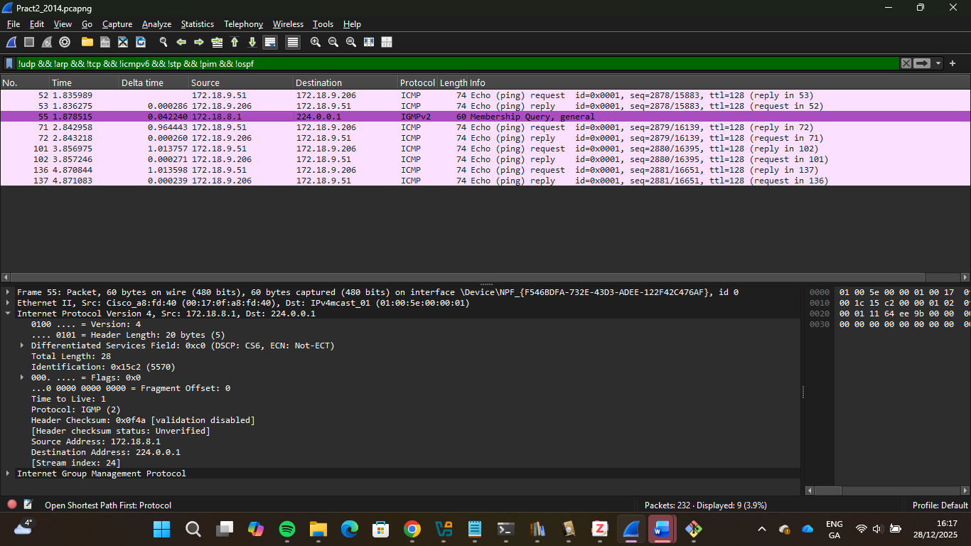

SECTION B
Question 1: What is the function of Packets 212 and 213?
Answer:
Packet 212 and Packet 213, present in the screenshot below, contain an Address Resolution Protocol(ARP) response-request cycle. ARP is a data link layer protocol that uses an IPv4 address to map MAC addresses (Physical Address) for communication between devices in a local area network (Fortinet, n.d.). When Packet 212’s source IPv4 address of 172.18.9.51 wants to communicate with Packet 213’s source IPv4 address of 172.18.9.206 in a network, Packet 212’s host device must know the MAC address of Packet 213’s host device, ARP then acts as the translator for Packet 212’s host device using the IP address of Packet 213’s host device to identify the MAC address of Packet 213’s host device which is displayed as 00:25:64:b4:a4:d9 in the screenshot below.
The ARP request consists of packet data transmitted within an appropriate Layer 2 frame for the channel in use, typically an Ethernet frame. The Ethernet header includes three fields: A source MAC address, which is the MAC address of the source host device, A destination MAC address, which is a broadcast address of ff:ff:ff:ff:ff:ff that indicates a broadcast frame, and an Ethertype containing the protocol of the transmitted Packet. An ARP payload consists of multiple fields, such as(Harmoush, 2017):
1. Hardware type and protocol fields that signify the address types being mapped together, e.g.MAC address to IPv4 address mapping.
2. Hardware size and Protocol size that indicate the the amount of bytes contained in the addresses for the hardware type and protocol type.
3. Sender MAC and IP addresses
4. Target MAC and IP addresses
The ARP response consists of a similar Packet structure to the ARP request, consisting of similar Ethernet headers and ARP payload fields, with the significant difference being the initial source host in the ARP request becoming the target host and the initial target host in the ARP request becoming the source host(Harmoush, 2017). Packer 212 and 213, displayed in the screenshot below, highlight a default ARP process request between a source host initiating the ARP process with the target host to obtain the target host’s MAC address and cache the address in its ARP table.

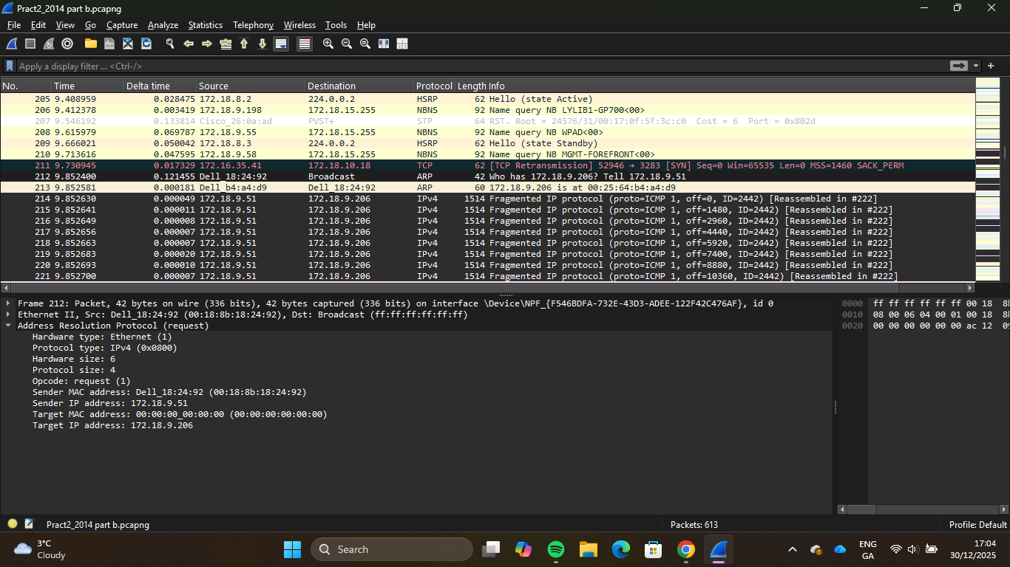

Question 2: Describe the data properties of the Packet in 222?
Answer:
The screenshot below highlights Packet 222, an ICMP echo request of 202 bytes encapsulated in an IPv4 Packet that is then encapsulated in an Ethernet frame for communication on the local network. It was transmitted from a host device with a source IPv4 address of 172.18.9.51 and got a corresponding ICMP echo reply from Packet 233’s host device with a source address of 172.18.9.206.
Frame Layer Encapsulation:
1. Frame Number: 222, this indicates the sequential number assigned by Wireshark based on when the network traffic was captured.
2. Encapsulation Type: Ethernet(1), this specifies the framing format used to transmit Packets across a network.
3. Arrival Time: 2014-02-05 T13:48:48.614923, timestamp of when the Packet was captured, sound during Packet timing analysis
4. Capture length: 202 bytes captured, which indicates the quantity of Packets stored, 202 bytes on wire, which indicates the size of the frame captured during transmission, the capture length of 202 bytes captured and 202 bytes on the wire means all the data captured during transmission was recorded in Wireshark.
5. Protocols in Frame: eth:ethertype:ip:icmp: data, lists all protocols present in the frame from the physical layer to the application layer.
Ethernet Layer Encapsulation:
1. Destination MAC address: 00:25:64:b4:a4:d9, this identifies the specific device on the local network that will receive the Ethernet frame.
2. Source MAC address: 00:18:8b:18:24:92, this identifies the device on the internal network sending the Ethernet frame out.
3. Type: IPv4. This signals the receiving device that the Ethernet data payload should be processed as IPv4.
IPv4 Encapsulation:
1. Source IP: 172.18.9.51, which identifies the source host IPv4 address .
2. Destination IP: 172.18.9.206, which identifies the target host IPv4 address.
3. Total Length: 188. This fragment is 188 bytes total, including the header and data
4. Time to Live: 128, Can pass through 128 routers before being dropped
5. Protocol: ICMP (1), this indicates the frame is carrying ICMP data (ping/traceroute)
6. Fragments Reassembly: There are 9 IPv4 Fragments that combine to add up to 12008 bytes. The original Packet was 12,008 bytes in total and was split into nine fragments, numbered from 214 through 222. Most fragments are 1480 bytes; The Last fragment of 222 is only 168 bytes.
ICMP Encapsulation:
1. Type: Echo ping request(8), an echo request asking the corresponding device to respond through an echo reply.
2. Code: 0, this provides more detail about the echo request type; however, an echo request code is always 0. Some other ICMP types use code to specify different subtypes of messages(IANA, 2025).
3. Response frame: 233. Frame 233 would be the specific Packet captured that corresponds to this ICMP request or response.
4. Data: 12,000 bytes. The ICMP Echo Request carries 12,000 bytes of encapsulated data.
The data properties of Packet 222 show the role of each layer and their interoperability, how a large volume of data is transmitted over a network through fragmentation, and the communication methods between devices in a local network.
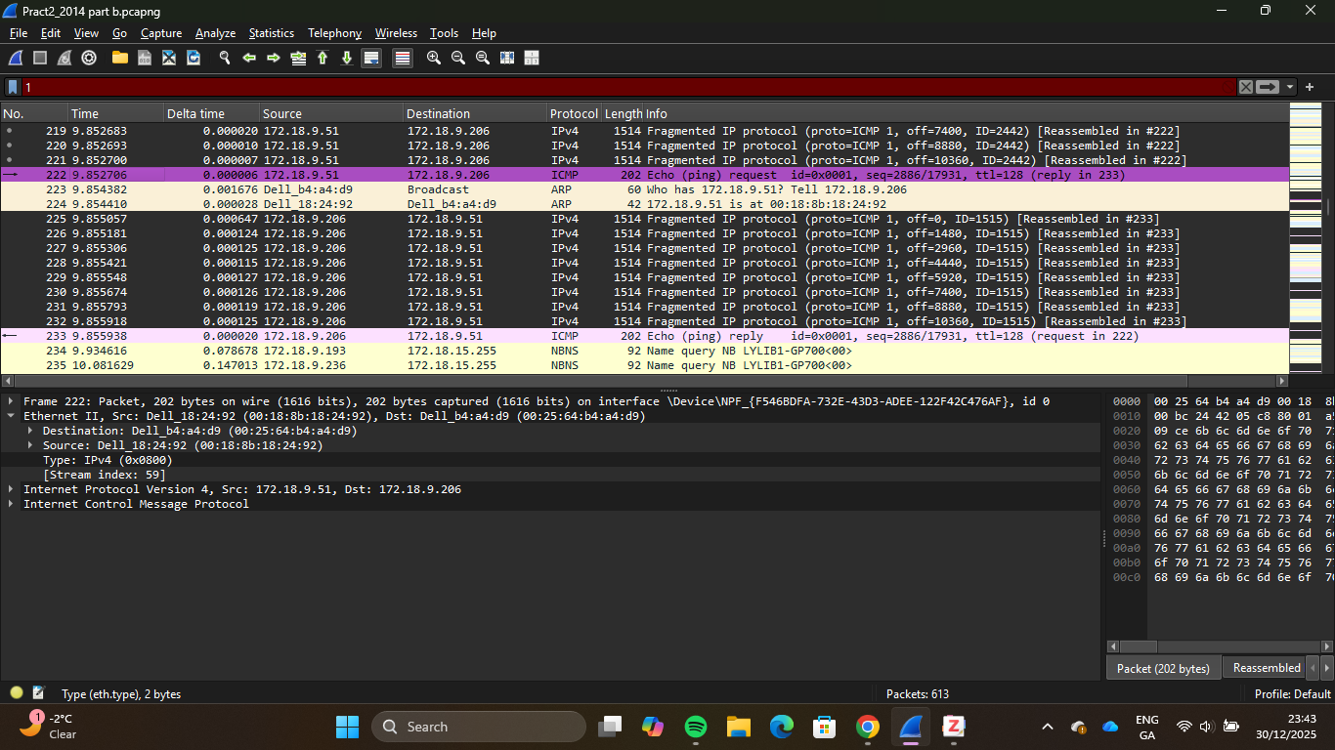

Question 3: How many Packets were used to perform the request?
Answer:
The Screenshot below details nine Packets used to perform an ICMP echo request operation, displayed in Packet 222. Packet 222 represents a reassembled ICMP echo request, which was fragmented during transmission due to the size of the echo request, as indicated in the screenshot below, with the IPv4 fragments section highlighting fragments 214 to 222. The screenshot shows the fragmented IP protocols of the Packets in the Packet list, each marked as “Fragmented IP Protocol(Proto=ICMP1)”, along with different IDs and offset values, which Wireshark reassembled into the complete 12,008-byte ICMP echo request shown in Packet 222.
Each of the nine Packets consists of a section of the original 12,008-byte ICMP echo request Packet; Packets 214 to 221 carry the maximum transmission unit size of 1,480 bytes (Cloudflare, n.d.), and the final Packet 222 contains the remaining 168 bytes of data. Offset values are displayed in each Packet's information column, ranging from off=0 for the initial fragment through off=10368 for the final fragment, allowing the receiving host device to reassemble the original message in the correct order. All fragments share the same identification number, 2442, as shown in the Packet details in the screenshot below, enabling the receiving host device to treat these separate Packets as a single unit.
The requirement of multiple Packets for a single ICMP echo request is due to IP fragmentation, which occurs when the Packet size exceeds the maximum transfer unit of a device on the network route (Cloudflare, n.d.). IP fragmentation indicates that the ping operation was executed with a large Packet size. The successful reassembly of the fragments and the corresponding reply, as shown in the Wireshark screenshot below, demonstrate that the network route handled fragments without Packet loss or reordering issues.
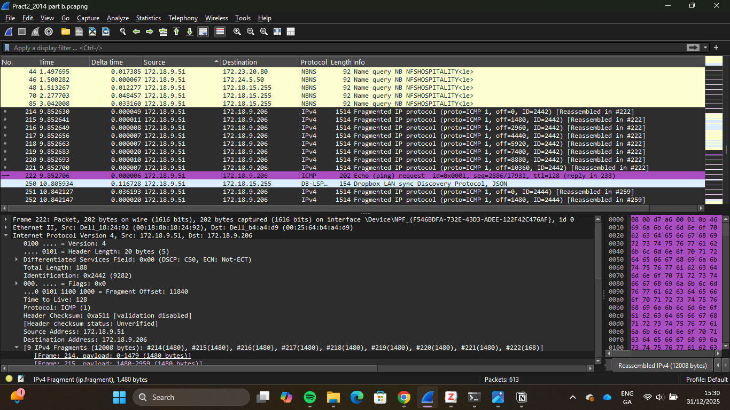

Question 4: Use the filter frame.len==1514 – how many Packets are returned?
Answer:
The Screenshot below details 160 Packets of different fragmented ICMP echo request operations. “The frame.len==1514” filter was used to filter for IP fragments captured in the network traffic as frame.len is a filter that is used to sort data through the ethernet frame size, 1514 is the typical size of a full ethernet frame carrying a maximum sized IPv4 Packet(Molenaar, 2014), Wireshark precisely shows these Packets whose total length is 1514, which correspond with IP Packets that were too large to fit into a single path and were therefore fragmented during the transmission of the Packet data.
The Packet fragments are split into forward routes and return routes. The forward route consists of a device with a source host IPv4 address of 172.18.9.51 and a destination host IPv4 address of 172.18.9.206; the return route consists of the reverse path of the forward route. Sections of Packets share the same ID but different offset values, enabling devices to group the Packets into a collective and in the correct order, as shown in the screenshot below. All the Packets also use the fragmented IP protocol, which means they are smaller fragments of the original IP Packet (JumpCloud, 2025).
The Maximum transmission unit (MTU) of 1514 bytes for Ethernet frames, enforced to prevent fragmentation, is essential for the security it provides against data loss over unreliable routes (Sheehan, 2025). The successful reassembly of the multiple fragments, the lack of Packet loss between both devices, the initial request from host device and corresponding reply from the target device establishes a reliable pattern of network connectivity, establishes the forward and return route for both devices can handle large data Packets, multiple successful replies to large Packets also confirms that ICMP is fully permitted between both devices.
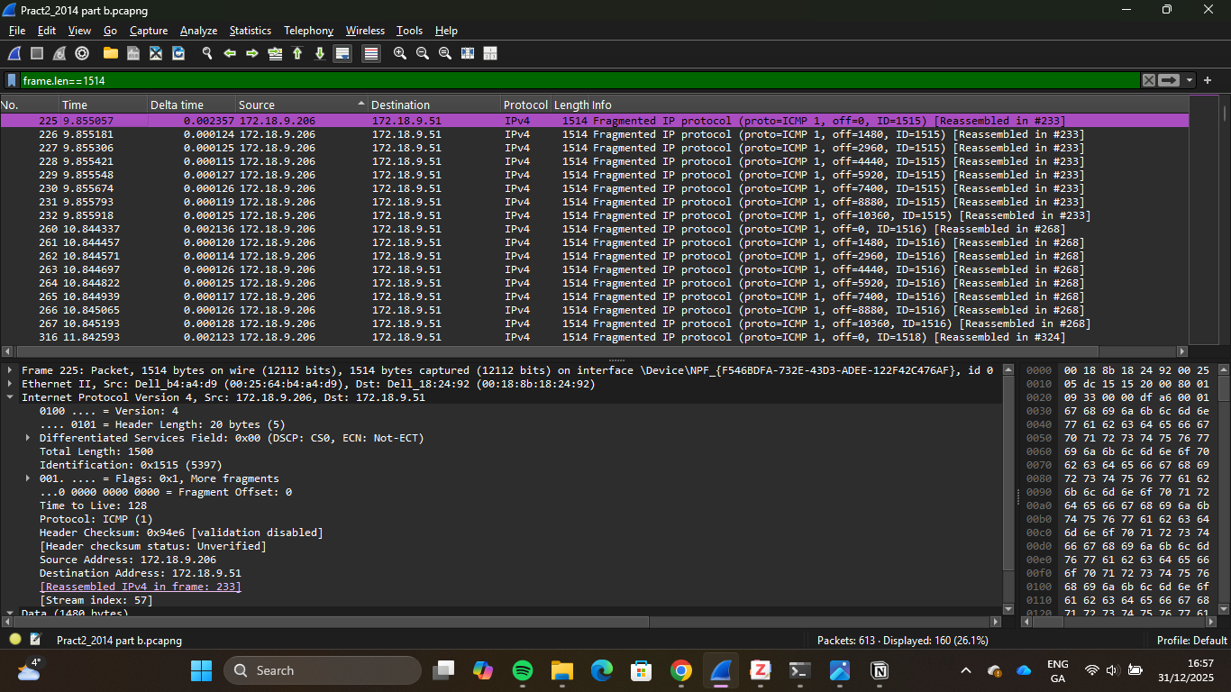

Question 5: What is fragmentation?
Answer:
The screenshot below highlights a list of fragmented IP Packets for an ICMP ping echo operation. Fragmentation is the process of breaking a single datagram into smaller parts, called fragments. This occurs when the datagrams exceed the maximum transmission unit of the network device through which they are transmitted (Singh, 2025). Maximum Transmission Unit is the maximum size, measured in bytes, forwardable by a layer; the Ethernet layer can forward up to 1514 bytes, with 1500 bytes as the Packet data and 14 bytes as the Ethernet header (Molenaar, 2014). Fragmentation also introduces latency into network communications, so its use should be avoided in the network wherever possible (Cloudflare, n.d.).
Fragmentation occurs at network routers, where the size of received IP Packets is checked against the MTU of the subsequent router that will accept them. If the size of the Packet exceeds the MTU of the next router, the first router breaks the payload into two or more Packets, and assigns headers to each Packet, the new header is copied from the original Packet, which means all the fragmented Packets contain details of the original Packet with some changes such as the router adding fields in the IP header to indicate the Packets are fragmented require reassembly, the quantity of total Packets, and the order in which they are transferred(Cloudflare, n.d.).
Fragmentation is limited in its application; for example, it is not permitted in IPv6 because routers cannot fragment IPv6 Packets. Fragmentation is also prevented when the “Don’t Fragment” flag is set in a packet’s IP header, because routers inspect packets for this flag. If the size of the Packet exceeds the next router’s MTU, the Packet will be dropped instead of being fragmented(Cloudflare, n.d.). A fragmentation attack is a type of attack that disrupts reassembly by manipulating data Packets to compromise systems or gain unauthorised access. Fragmentation attacks work by breaking data into smaller segments, manipulating Packet headers, overloading target systems, and exploiting weak protocols. These attacks can be mitigated through the strengthening of network defences, configuration of Packet policies, staff training, network monitoring, and security updates (Startupdefense, n.d.).

Question 6: Why is there no DNS request or reply for the two hosts involved in ICMP communication?
Answer:
DNS resolves hostnames to IP addresses; there is no DNS request or reply between the two hosts, as shown in the screenshot below, because both devices communicate via IP addresses and no hostname is involved. ICMP operates directly with IP addresses. Once they are known, if both hosts are aware of the other’s IP addresses, then no DNS query happens. DNS is not part of the ICMP protocol because DNS is an application-layer protocol (Srijan, 2025), while ICMP operates at the network layer. A DNS query will only occur if an ICMP ping/traceroute operation is executed with a hostname.
Even in situations where hostnames are used in ICMP commands, DNS may not appear in the Packet capture due to DNS caching. DNS caching is a temporary storage system that keeps records of recent IP-to-domain name mappings to improve response times for future requests. The network device checks the cache before querying a DNS server for every IP lookup request (Malla, 2025). This creates a situation where ICMP Packets flow between hosts without any visible DNS traffic in the capture, even when a hostname was used in the ICMP operation.
DNS servers are not the only method used in the resolution of IP addresses, hostnames can also be resolved through local host file resolution, local host file entries possess the additional advantage of the system being able to run the application server, even when disconnected from the network which enhance self sufficiency by reducing dependency on external DNS servers and ensuring uptime in the event of loss in network connectivity. For functionality, the file must be configured to include the IP address of the computer, the fully qualified domain name of the computer, the hostname of the computer, the IPv4 address 127.0.0.1, the fully qualified domain name of localhost.localdomain, and the name localhost (IBM, 2021).
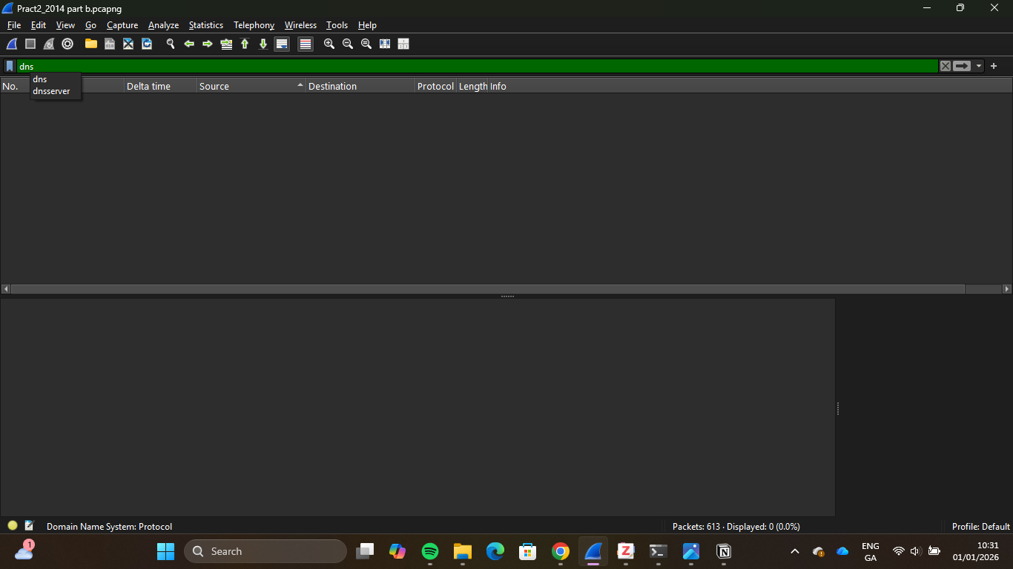

Question 7: What protocol is used instead?
Answer:
ARP is the protocol used to facilitate ICMP communication between two host devices. In ICMP communication, once IP addresses are known, ARP becomes critical for communication between hosts on an internal network, mapping IP addresses to MAC addresses. When an ICMP Packet needs to be transferred from one host to another in a local network, the source host device must encapsulate the ICMP Packet within an ethernet frame, which requires knowledge of the destination MAC address, if the destination MAC address associated with the target IPv4 address is not already present in the source host’s ARP table, an ARP request is then initiated by the source host device to obtain the target MAC address that will be encapsulated into the ethernet frame.
When a host device on a local network requires communication to a target device, the host device requires the MAC address corresponding to the target device’s IPv4 address to generate a layer two header, if the MAC address is not already stored in the ARP table, an ARP request is initiated by the device as a broadcast to all devices on the local network segment, upon receiving the request, all devices in the local network analyse the target IPv4 address within the Packet and the device with a matching IPv4 address responds with an ARP reply which is sent as a unicast directly to the host device, and once the host device receives the answer, it updates its ARP cache mapping the IPv4 address to the new MAC address which allows for subsequent communication between devices while bypassing the ARP request-response cycle(Thummaluru, 2025).
ARP is vulnerable to multiple threats, including ARP spoofing attacks, excessive broadcast traffic generation that can lead to network congestion, the absence of verification features to distinguish legitimate device identities, and unauthorised access through attackers responding to authentic requests to gain access to sensitive network communications. These challenges can be mitigated through the implementation of static ARP entries in critical network zones, enabling dynamic ARP inspection on switches, enforcing physical and wireless access controls, using VPNs and encryption to protect transported data(Fortinet, n.d.).
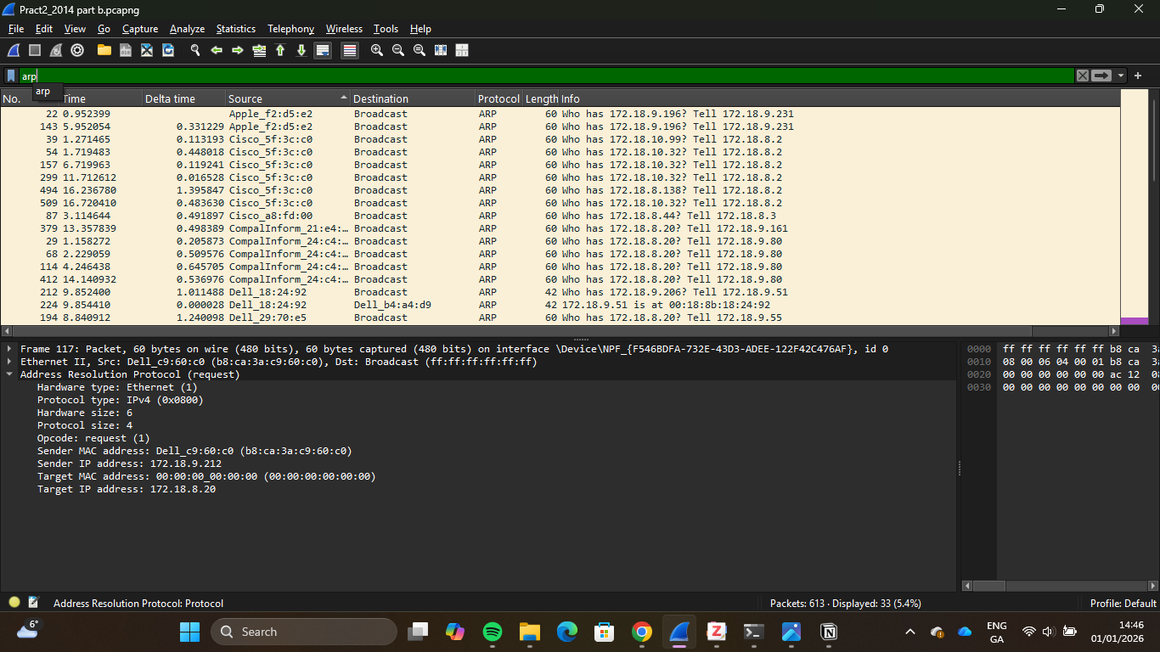

Question 8: What would the filter be to isolate this traffic? How many Packets are returned?
Answer:
To isolate ARP traffic during network analysis, the arp display filter can be used for network analysis tools such as Wireshark, as displayed in the screenshot below. This filter expression would return only results for Packets that use the Address Resolution Protocol, filtering out all other Packets that use TCP, UDP, ICMP, and other such protocols. There are 33 returned Packets, as shown in the screenshot below; all 33 Packets use ARP, consisting of ARP requests and ARP responses. The disproportionate difference between ARP requests and ARP responses, however, indicates the unavailability of several IPv4 addresses in the network, either because they do not exist or are offline.
ARP scanning is a technique used to discover active hosts on an internal network. An attacker could use it to illustrate the local network topology and identify targets via ARP replies. An “arp-scan [OPTIONS] [HOSTS]” is a command that executes based on the set parameters, with [OPTIONS] involving the different types of ARP scans and [HOSTS] involving a device or range of devices that will be scanned by the arp-scan(hackingloopscontact, 2016). This method of attack is dangerous because all IPv4 devices automatically respond to ARP queries, and disabling this response renders the device unable to communicate with other network devices, forcing all network devices to be visible via ARP queries (Cybrary, 2020).
A low volume of ARP replies to ARP requests could also indicate ARP spoofing, in which a malicious attacker sends fake ARP messages to an internal network. This attack method is a man-in-the-middle attack that exploits ARP's lack of authentication; it involves an attacker sending malicious ARP replies that trick a device into sending data to a MAC address under the attacker’s control. The effects of ARP spoofing can be mitigated through static ARP entries, Packet filtering, and the use of VPNs (SentinelOne, 2024). While ARP scanning is a non-invasive method used for legitimate purposes, ARP spoofing is an invasive, malicious attack used for illegitimate purposes.

Question 9: How many arp Packets came from the source client machine? What filter is used?
Answer:
Two ARP Packets were returned in Wireshark after applying the arp.src.proto_ipv4 ==172.18.9.51 to the Packet capture as displayed in the screenshot below, this indicates that the source client machine generated 2 ARP operations during the network traffic capture, which includes the ARP request initiated by the source client machine to discover the MAC address of a target client machine and a corresponding ARP reply to the target machine containing its MAC address. The two ARP Packets represent different communication types: Packet 212 is a broadcast frame, and Packet 224 is a unicast frame, as shown in the screenshot below.
The source client machine is identified as a device with an IPv4 address of 172.18.9.51 and a MAC address of 00:18:8b:18:24:92, as shown in the Wireshark capture in the screenshot below. The identification was established using timestamps and ARP requests: arp to identify all arp packets, arp.opcode==1 to identify the device that sent the first ARP request, and then arp.opcode==2 to identify the devices that received an ARP reply. The Packet 212 displays “Who has 172.18.9.206? Tell 172.18.9.51" in the information column as displayed in the screenshot below, which indicates that the source device with an IPv4 address of 172.18.9.51 initiated an ARP request to discover the MAC address of the target device with an IPv4 address of 172.18.9.206. The Packet details at the bottom of the screenshot also reference the addresses in the sender IP address and target IP address fields within the address resolution protocol section.
The filter used to obtain the ARP packets from the source client machine is “arp.src.proto_ipv4 == [IP address]” as displayed in the screenshot below, where the “[IP address]” placeholder is replaced by the source client’s IP address(mahmoud, 2025). The filter captures ARP response and reply Packets containing the listed IP address. This is useful when a network analyst wants to observe the ARP process of a device with a specific IPv4 address in the network. MAC addresses can be used to obtain the source client machine through the “arp && eth.src=[MAC address](Anderson, 2023). This filter uses the and operator to combine the ARP filter and the source MAC address filter, displaying all ARP instances for the 172.18.9.51 device.
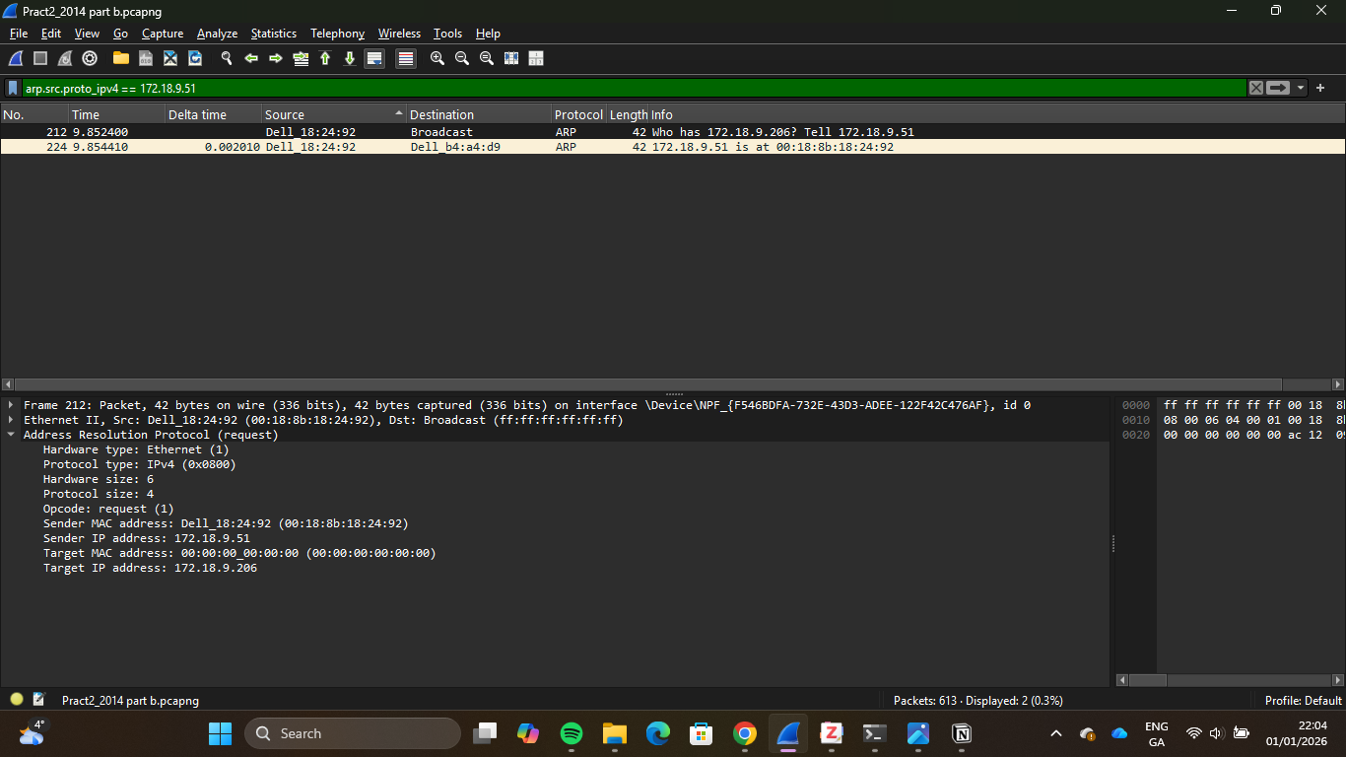

Question 10: Create the I/O graph below and enter the three filters below.
Answer:
The I/O graph was created in Wireshark by navigating to the I/O graph feature in the statistics menu, which opened a graphical interface for observing ARP Packets over time. Three separate display filters were configured in the I/O graph configuration section to compare different types of ARP traffic. The first filter, arp, was used to display all Packets containing ARP in the captured traffic. The second filter, arp.opcode==1, was used to display all ARP requests in the captured traffic. The third filter, arp.opcode==2, was used to display all ARP replies in the captured traffic. Each filter was assigned a unique colour in the graph to distinguish it from the others. The Y-axis represents Packet count per time interval, with a scale ranging from 0 to 50 Packets, and the X-axis represents the passed time in seconds, spanning 16 seconds for the traffic capture session. The I/O graph’s time interval was set to 1 second, as displayed in the screenshot below, to provide depth for analysing the correlation of the different ARP Packets.
The I/O graph displayed in the screenshot below reveals distinct signs of activity, with the graph showing a spike of arp replies at the 9th second after being flat during most of the capture session and ending immediately after the spike which indicates no other arp replies were transmitted, this denotes successful arp replies for specific arp requests made during that period, unlike continuous requests that had previously been made but received no response as indicated by the graph in the screenshot below. The ARP Packets also experienced the only spike and change in movement from ARP requests due to a temporary spike in ARP replies in the 9th second. The overlap pattern between ARP request Packets and ARP Packets indicates that devices on the network continuously sent ARP requests to resolve IP addresses to MAC addresses; however, they received no corresponding ARP replies for most of the capture session.
An I/O graph is a visual representation of network traffic captured during a specific timeframe. It plots network metrics, such as Packets per second, over time, providing a convenient visualisation of network traffic patterns. It consists of several key components, such as the X-axis which represents tthe ime frame of the Packet capture, the Y-axis, which means traffic volume, data points, which represent volume of traffic in a specific time interval, and the ability to add multiple graphs to compare traffic flows or protocols. The graph allows analysts to observe spikes, trends or anomalies that can indicate network issues or security concerns. It is helpful during the sorting through extensive data, identifying network latency, troubleshooting network performance, and identifying malicious traffic on the network (Cyberly, n.d.).
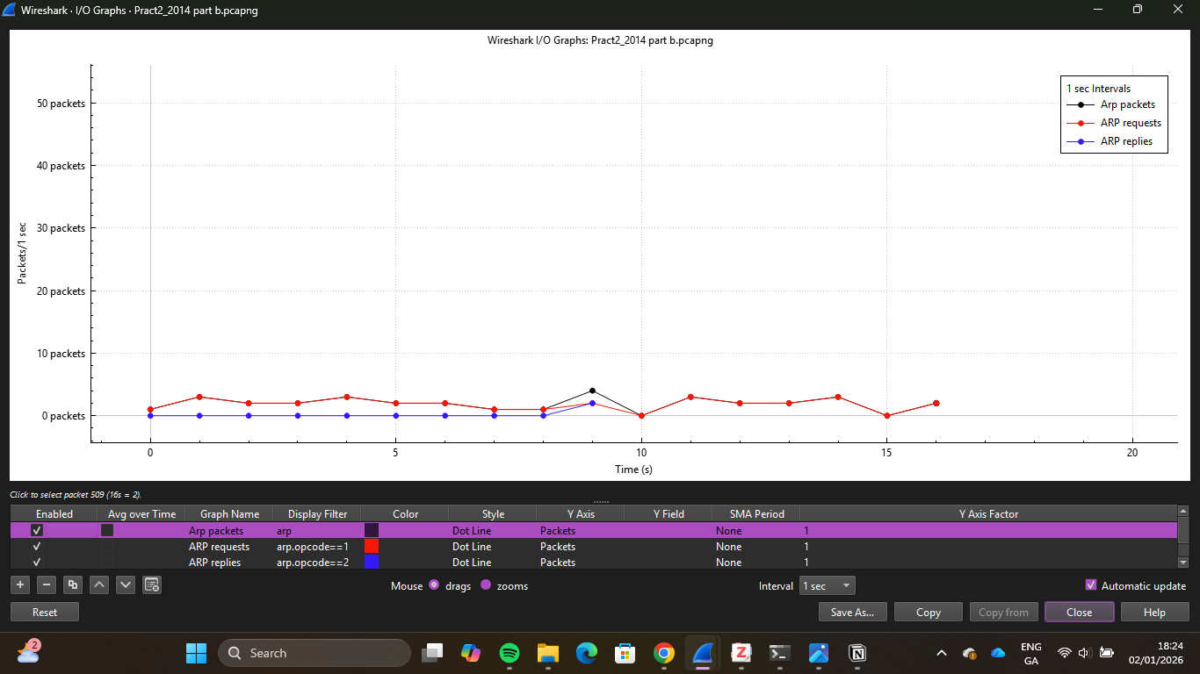

References:
IANA 2025. Protocol Numbers. [Accessed 17 December 2025]. Available from: https://www.iana.org/assignments/protocol-numbers/protocol-numbers.xhtml.
AngryIPScanner n.d. Angry IP Scanner - TTL. [Accessed 17 December 2025]. Available from: https://angryip.org/faq/TTL.
Smith, C. 2024. Common Ports Cheat Sheet | NetworkProGuide. [Accessed 17 December 2025]. Available from: https://networkproguide.com/common-ports-cheat-sheet/.
Alexandrea, Lim, J., Simon 2022. What is a Fully Qualified Domain Name (FQDN)? [Accessed 27 December 2025]. Available from: https://www.hostinger.com/tutorials/fqdn.
Anderson, D. 2023. How to Find MAC Address with WireShark. Alphr. [Online]. [Accessed 1 January 2026]. Available from: https://www.alphr.com/wireshark-find-mac-address/.
Anon 2023. ICMP – Internet Control Message Protocol in Computer Networks [Online]. [Accessed 28 December 2025]. Available from: https://www.youtube.com/watch?v=-FaGF6s3rJ8.
Brightwood, N. 2024. IGMP v2 vs. v3: A Comprehensive Comparison for Network Efficiency. [Accessed 28 December 2025]. Available from: https://netseccloud.com/igmp-v2-vs-v3.
Cloudflare n.d. What is MTU (maximum transmission unit)? [Accessed 31 December 2025]. Available from: https://www.cloudflare.com/learning/network-layer/what-is-mtu/.
Cyberly n.d. What Is The Wireshark IO Graph Used For? [Accessed 1 January 2026]. Available from: https://www.cyberly.org/en/what-is-the-wireshark-io-graph-used-for/.
Cybrary 2020. Why Use ARP Scan | Cybrary. [Accessed 1 January 2026]. Available from: https://www.cybrary.it/blog/why-use-arp-scan.
Daniel 2021. Neighbor Discovery Protocol - NDP Overview. Study CCNA. [Online]. [Accessed 27 December 2025]. Available from: https://study-ccna.com/ndp-neighbor-discovery-protocol/.
Flackbox 2021. Subnetting on the 3rd and 4th Octet - examples. FlackBox. [Online]. [Accessed 27 December 2025]. Available from: https://www.flackbox.com/ip-subnetting-examples.
Fortinet n.d. What Is ARP (Address Resolution Protocol)? How Does It Work? Fortinet. [Online]. [Accessed 30 December 2025]. Available from: https://www.fortinet.com/resources/cyberglossary/what-is-arp.
Gantenbein, K. 2021. What is ICMP Tunneling and How to Protect Against It — ExtraHop. [Accessed 28 December 2025]. Available from: https://www.extrahop.com/blog/detect-and-stop-icmp-tunneling.
Grinberg, S. 2025. What is a Ping Flood | ICMP Flood DDoS Attack | Imperva. Learning Center. [Online]. [Accessed 28 December 2025]. Available from: https://www.imperva.com/learn/ddos/ping-icmp-flood/.
hackingloopscontact 2016. How to Perform ARP Scans. Learn Ethical Hacking and Penetration Testing Online. [Online]. [Accessed 1 January 2026]. Available from: https://www.hackingloops.com/arp-scans/.
Harmoush, E. 2017. Traditional ARP – Address Resolution Protocol. Practical Networking .net. [Online]. [Accessed 1 January 2026]. Available from: https://www.practicalnetworking.net/series/arp/traditional-arp/.
IANA 2025. Protocol Numbers. [Accessed 17 December 2025]. Available from: https://www.iana.org/assignments/protocol-numbers/protocol-numbers.xhtml.
IBM 2024. AIX. [Accessed 27 December 2025]. Available from: https://www.ibm.com/docs/pl/aix/7.2.0?topic=p-ping-command.
IBM 2021. IBM Security Access Manager for Enterprise Single Sign-On. [Accessed 1 January 2026]. Available from: https://www.ibm.com/docs/en/samfess/8.2.2?topic=tasks-ways-resolving-hosts-ip-addresses.
Iveson, S. 2019. IP Time to Live (TTL) and Hop Limit Basics. [Accessed 27 December 2025]. Available from: https://packetpushers.net/blog/ip-time-to-live-and-hop-limit-basics/.
JumpCloud 2025. What Is IP Fragmentation? JumpCloud. [Online]. [Accessed 31 December 2025]. Available from: https://jumpcloud.com/it-index/what-is-ip-fragmentation.
Kaplarevic, V. 2024. DNS Record Types Explained. Knowledge Base by phoenixNAP. [Online]. [Accessed 26 December 2025]. Available from: https://phoenixnap.com/kb/dns-record-types.
M, P. 2023. Understanding the Ping Command on Windows vs Linux and Mac. Develop and Solve. [Online]. [Accessed 27 December 2025]. Available from: https://developnsolve.com/understanding-the-ping-command-on-windows-vs-linux-and-mac.
mahmoud 2025. Network Forensics with wireshark | Network Forensics | DFIR-Notes. [Accessed 1 January 2026]. Available from: https://mahmoud-shaker.gitbook.io/dfir-notes/network-forensics.
Malla, J. 2025. What is DNS Caching. GeeksforGeeks. [Online]. [Accessed 1 January 2026]. Available from: https://www.geeksforgeeks.org/computer-networks/what-is-dns-caching/.
Molenaar, R. 2015. IGMP Version 2. NetworkLessons.com. [Online]. [Accessed 28 December 2025]. Available from: https://networklessons.com/multicast/igmp-version-2.
Molenaar, R. 2014. MTU Troubleshooting on Cisco IOS. NetworkLessons.com. [Online]. [Accessed 31 December 2025]. Available from: https://networklessons.com/ip-routing/pppoe-mtu-troubleshooting-cisco-ios.
SentinelOne 2024. What is ARP Spoofing? Risks, Detection, and Prevention. SentinelOne. [Online]. [Accessed 1 January 2026]. Available from: https://www.sentinelone.com/cybersecurity-101/threat-intelligence/arp-spoofing/.
Sheehan, J. 2025. Understand IP Fragmentation: A Newbie Guide. SynchroNet. [Online]. [Accessed 31 December 2025]. Available from: https://synchronet.net/ip-fragmentation/.
Singh, A.K. 2025. Fragmentation in Network Layer. GeeksforGeeks. [Online]. [Accessed 31 December 2025]. Available from: https://www.geeksforgeeks.org/computer-networks/fragmentation-network-layer/.
Singh, N. 2025. Introduction To Subnetting. GeeksforGeeks. [Online]. [Accessed 27 December 2025]. Available from: https://www.geeksforgeeks.org/computer-networks/introduction-to-subnetting/.
Startupdefense n.d. Fragmentation Attack Basics: A Network Security Overview. [Accessed 31 December 2025]. Available from: https://www.startupdefense.io/cyberattacks/fragmentation-attack.
Techknowsurge 2022. Network Fundamentals 11-10: ICMP Basics - YouTube. [Accessed 27 December 2025]. Available from: https://www.youtube.com/watch?v=5EP1NZAu_PQ.
Thummaluru, M.K. 2025. ARP Internals: an in-depth exploration of how ARP functions. [Accessed 30 December 2025]. Available from: https://blogs.oracle.com/linux/arp-internals.
Utkarsh, K. 2025. Internet Group Management Protocol - IGMP. GeeksforGeeks. [Online]. [Accessed 28 December 2025]. Available from: https://www.geeksforgeeks.org/computer-networks/what-is-igmpinternet-group-management-protocol/.
Wireshark n.d. Chapter 9. Packet Dissection. [Accessed 3 January 2026]. Available from: https://www.wireshark.org/docs/wsdg_html_chunked/ChapterDissection.html.

